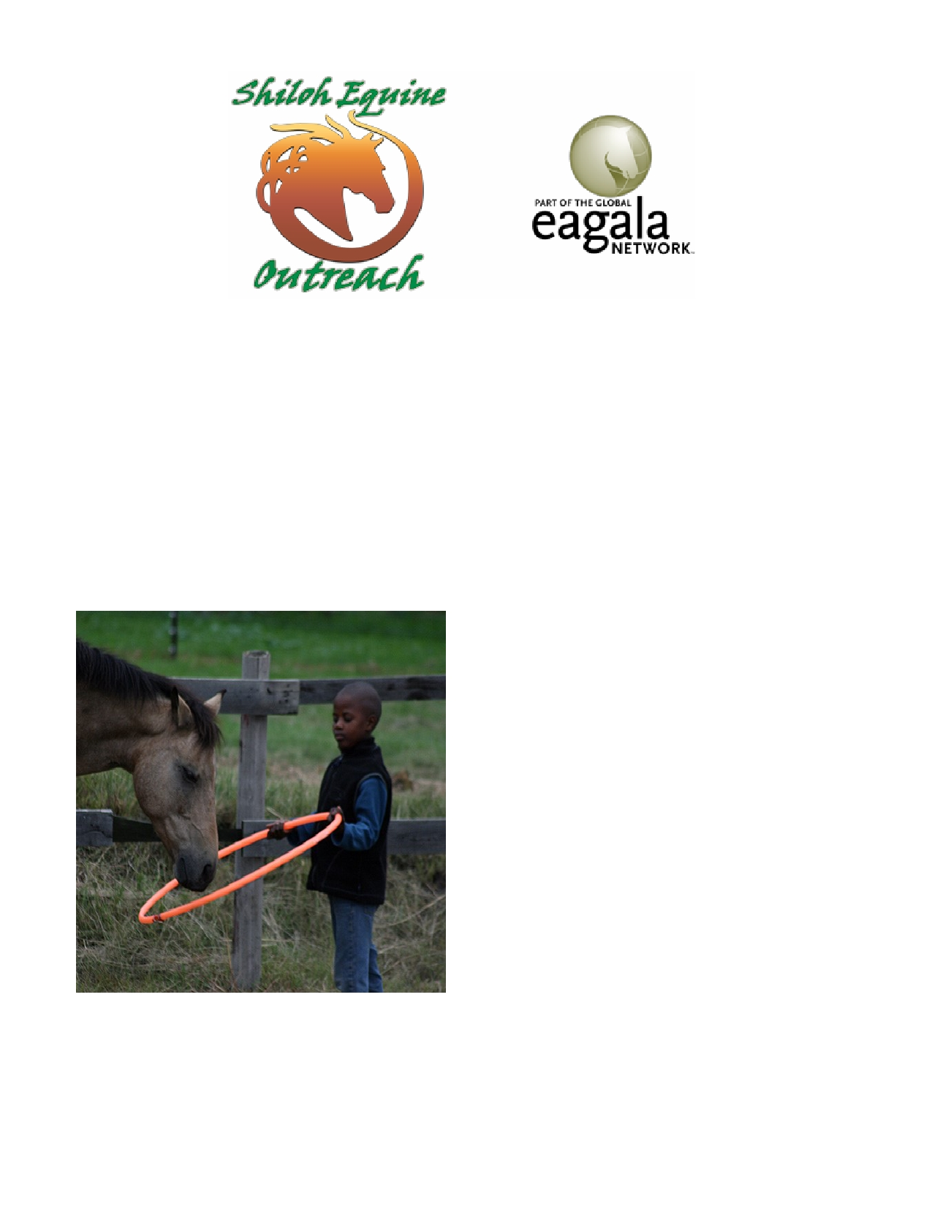Shiloh Equine Outreach is a nonprofit organization providing equine assisted psychotherapy to at
risk children and adolescents in grades 1- 12 throughout south Georgia.

• Equine Assisted Psychotherapy (EAP) incorporates an equine specialist, a mental health specialist,
and horse(s) in each session to facilitate personal growth and learning to aid in the process of re-
covery.
• Shiloh Equine Outreach provides an adjunct treatment strategy to current treatment plans to help
improve access to mental health services for our future generations.
• Our services are provided at no cost to the family with no requirements or limitations regarding
insurance coverage.

Our program is EAGALA (Equine Assisted Growth and Learning Association) certified and follows all
EAGALA models and methods. We also offer vol-
unteer opportunities for those students looking
to fulfill community service requirements and will
offer scholarship opportunities for students who
meet eligibility requirements.
Children and adolescents with ADHD, anxiety dis-
orders, bereavement, depression; those suffering
through trauma, abuse, loss; or those with trou-
ble in school from bullying or social struggles
could potentially benefit from our program ser-
vices.
Please visit our website to learn more about our program!

www.shilohequineoutreach.org

sgee@shilohequineoutreach.org 229-561-3620

Stephanie S Gee, MD Executive Director Edna Cooper, EAGALA certified equine specialist

Shiloh Equine Outreach 7029 Parker Rd Hahira, GA 31632

